Building an artificial protective skin for emerging energy materials

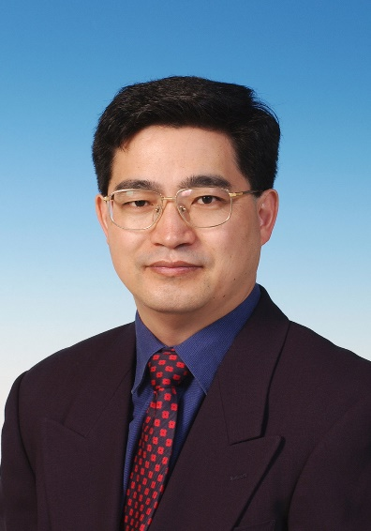
Professor Guohua Chen
Department of Mechanical Engineering
The Hong Kong Polytechnic University

Wednesday, August 15
11am to 12pm
BA 2145

Abstract:

Layered lithium transition metal oxides are promising cathode materials for next generation lithium-ion batteries because of their high capacity and low cost. However, they suffer from crystal and interfacial structure instability under aggressive electrochemical and thermal driving force, leading to rapid performance degradation and severe safety concerns. In this work, an innovative approach is reported by building an artificial protective conductive polymer (PEDOT) skin on LiNi_{1/3}Co_{1/3}Mn_{1/3}O₂ (NCM111) cathode material to remarkably enhance its capacity and voltage stability as well as thermal stability under high-voltage (4.6 V) operation. The ultra-conformal, highly electronically conductive and ionically permeable PEDOT skin can facilitate the breathing of lithium ions and electrons during charge-discharge, significantly suppress the undesired layered to spinel/rock-salt phase transformation and the associated oxygen loss, mitigate intergranular and intragranular mechanical cracking, and stabilize cathode-electrolyte interface because of both physical protection of NCM111 and chemical scavenging of HF. Building an artificial skin at both secondary and primary particle levels for tailoring the functionality and chemistry of layered oxides offers a new design strategy for the emerging Ni-rich cathodes towards high-energy, long-life and very safe lithium-ion batteries.

Bio:

Professor Chen received his Bachelor of Engineering degree in Chemical Engineering from Dalian University of Technology in China. He then obtained the Master of Engineering degree and PhD degree from McGill University in Canada.

Professor Chen joined the Department of Chemical and Biomolecular Engineering of The Hong Kong University of Science and Technology (HKUST) as a Visiting Scholar in 1994, then as Assistant Professor in 1997, and rising through the academic ranks to Professor in 2008. Professor Chen has been the Head of the Department of Chemical and Biomolecular Engineering, HKUST, from 2012 to 2016. He joined the Department of Mechanical Engineering, Hong Kong Polytechnic University, as a Chair Professor in 2017. He serves as an Associate Vice President (Research Support), Hong Kong Polytechnic University.

Professor Chen was the 17th President of the Asian Pacific Confederation of Chemical Engineering, is the Vice President, World Chemical Engineering Council, Editor of Separation and Purification Technology. Professor Chen’s recent research interests include electrochemical technologies for energy and environmental applications. Professor Chen received the Certificate of Excellence from the World Forum of Crystallization, Filtration and Drying in 2007 and the inaugural Research Excellence Award from the School of Engineering of HKUST in 2011. He was elected as a Fellow of Hong Kong Institute of Engineers, and Fellow of American Institute of Chemical Engineers.

